Jake Orben

March 13, 2014

1. Source port 3025

Destination port 8080

1. No, they are not, and everything is sent through the same port unless otherwise specified. There is not much to explain or discuss, the server keeps port 80 open to listen for data. Furthermore each stream of data gets its own socket to allow for data communication.
2. T/F
   1. False
   2. True
   3. True
   4. False
   5. True
   6. False
   7. True
3. Host TCP A and B
   1. Sequence number 409, source port number 1028, destination port 80
   2. Acknowledgement number 409, port number 80, destination port number 1028
   3. Acknowledgement number 359, source port number 80, destination port 1028
   4. 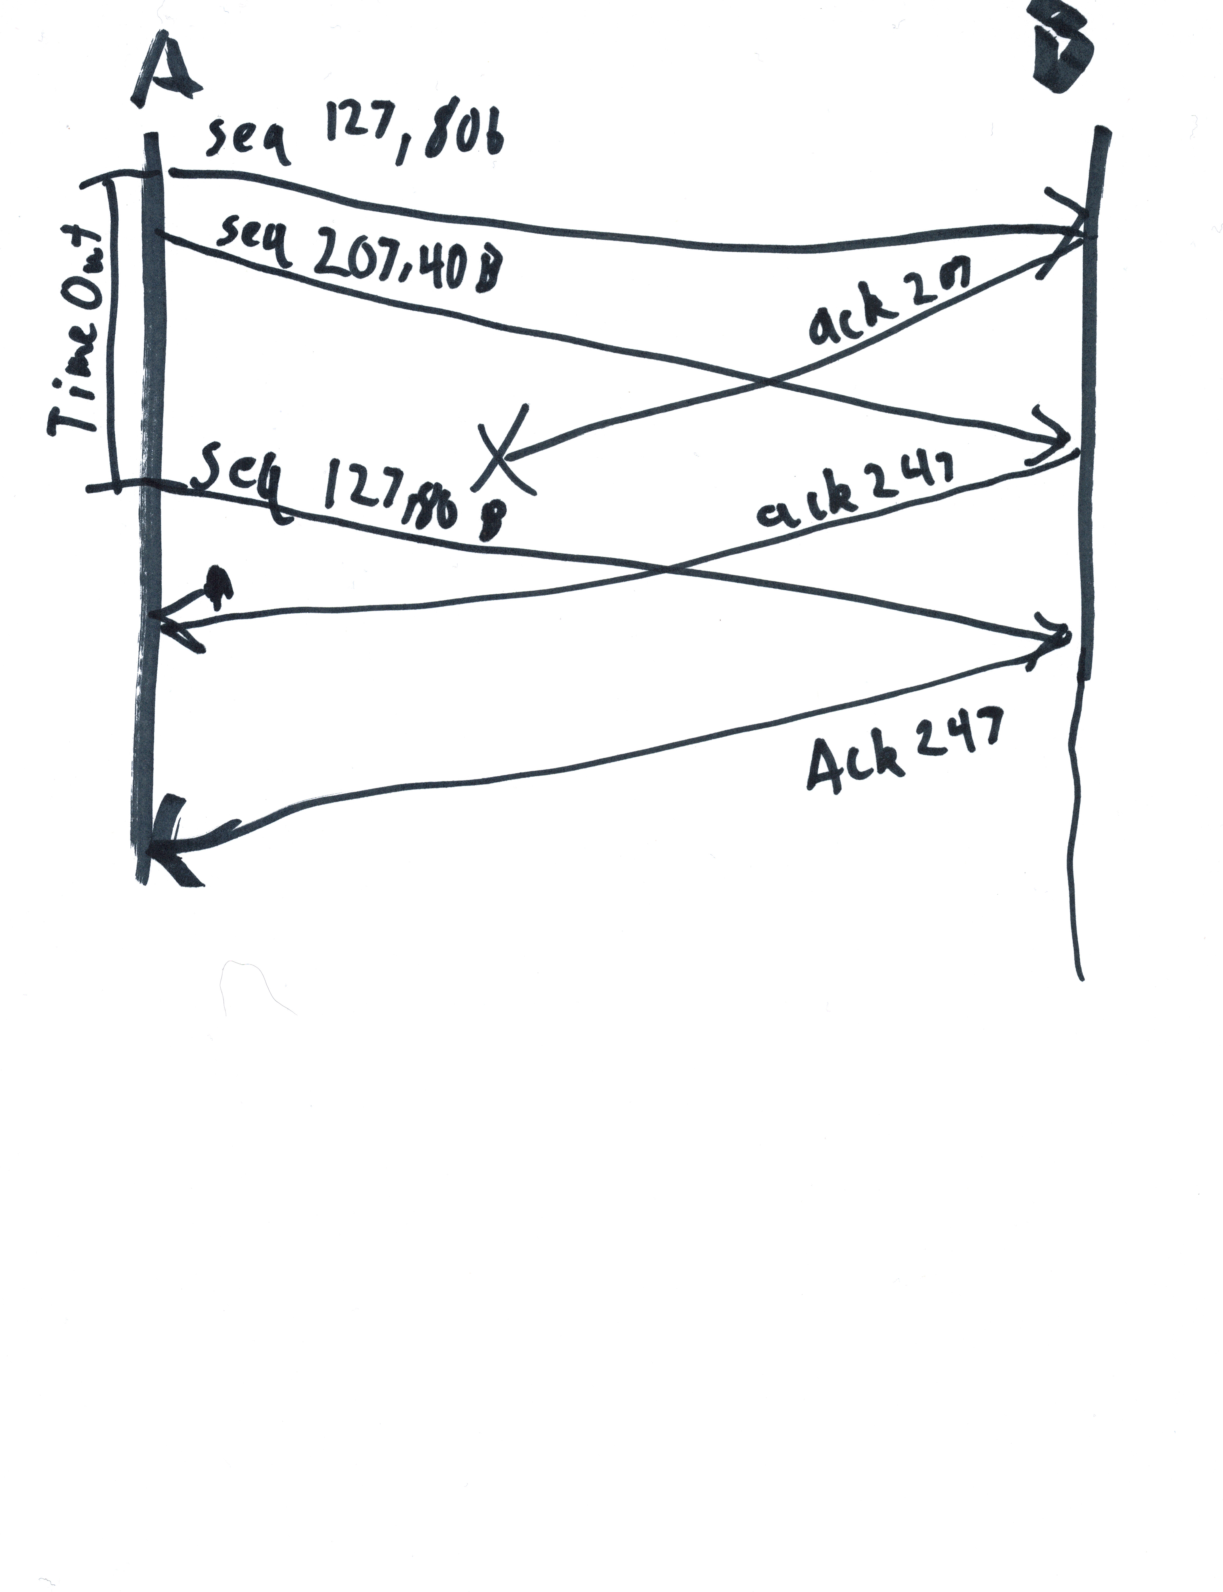
4. Graph questions
   1. 1-6, 23-26 – lowest points on the graph
   2. 6-23 – point slope changes
   3. timeout – seen by dramatic drop
   4. timeout – seen by the dramatic drop
   5. 1
   6. 27
   7. 3
   8. triple request – no dramatic drop
   9. 4,4